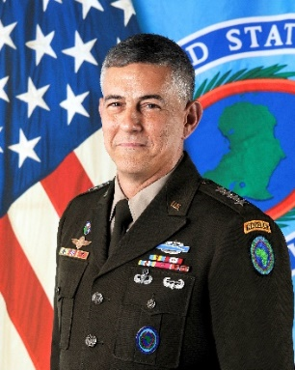
General Stephen J. Townsend, U.S. Army, became the fifth Commander of United States Africa Command in July 2019. Headquartered in Stuttgart, Germany, U.S. AFRICOM is one of six joint service geographic combatant commands and is responsible for all U.S. military operations and activities to protect and advance U.S. national interests in Africa.

General Townsend’s previous assignment was commanding U.S. Army Training and Doctrine Command where he oversaw all recruitment, training and education for America’s Army.

From Griffin, Georgia, General Townsend commissioned as an Army infantry officer upon graduation from North Georgia College in 1982. He has led and commanded troops at every echelon from rifle platoon to infantry division and Army corps as well as two combined/joint task forces.

General Townsend’s operational experience includes Operation Urgent Fury, Grenada; Operation Just Cause, Panama; Operation Uphold Democracy, Haiti; Operation Enduring Freedom, Afghanistan; Operation Iraqi Freedom, Iraq. In 2016-17, he led the multinational effort to defeat ISIS in Iraq and Syria during Operation Inherent Resolve.

His career includes service with four Army divisions, the 82d Airborne, 7th Light Infantry, 101st Air Assault and the 10th Mountain; the 75th Ranger Regiment; the separate 3d Stryker Brigade,
2d Infantry Division; as well as command of the XVIII Airborne Corps. His past joint assignments include U.S. Indo-Pacific Command, U.S. Central Command, the Joint Staff, Regional Command-East in Afghanistan and Combined/Joint Task Force-Operation Inherent Resolve in Iraq and Syria.

General Townsend holds two master’s degrees and military qualifications and awards appropriate to
his service as a career infantry officer.

General Townsend is married to Melissa, also from Georgia. They have two married sons, one an Army Captain, the other an Army veteran and university student. The Townsends happily spoil two grandchildren and two large and unruly dogs.

